

**Software Requirements Specification for**

**ONLINE EXAM REGISTRATION SYSTEM**

**PREPARED BY**: **GUIDED BY**:

**Utkarsh Singh Dr. H.K. Tripathy**

**Anurag Kumar**

**Kishan Kumar**

**Document Approval :**

The following Software Requirements Specification has been accepted and approved by the following:

**22051734 Utkarsh Singh (Research)**

**22051668 Anurag Kumar (ER Diagram,Activity Diagram,UML Diagram,Sequential Diagram,etc.)**

**22051689 Kishan Kumar(Document Prepartion)**

**Table of Contents**

**1. Introduction .........................................................1**

1.1 Purpose ...............................................................................................................1

1.2 Document Conventions ...........................................................................1

1.3 Product Scope .......................................................................................... 1

1.4 References ................................................................................................ 2

**2. Overall Description ...............................................2**

2.1 Product Perspective ................................................................................. 2

2.2 Product Functions .................................................................................... 2

2.3 Operating Environment ........................................................................... 3

2.4 Design and Implementation Constraints ............................................... 3

2.5 Assumptions and Dependencies ............................................................. 3

**3. External Interface Requirements ........................3**

3.1 User Interfaces .......................................................................................... 3

3.2 Hardware Interfaces ..................................................................................3

3.3 Software Interfaces ...................................................................................4

3.4 Communications Interfaces .................................................................... 4

**4. Functional Requirements .....................................4**

**5. Other Non-functional Requirements....................5**

5.1 Performance Requirements .....................................................................5

5.2 Safety and Security Requirements ......................................................... 5

5.3 Business Rules ..........................................................................................5

**1. Introduction :**

The web-based examination registration system simplifies and streamlines the process of managing exams, benefiting examiners, students, and administrators alike. Examiners can effortlessly create and manage exams, track results, and analyze performance, reducing the workload and ensuring efficiency. Students enjoy a transparent and accessible experience, with the ability to take exams online, view results, and receive feedback on past assessments. Administrators can seamlessly handle course and enrollment management, ensuring the system operates smoothly.

The user-friendly interface makes the platform accessible to all, while secure login authentication safeguards data. Students can access study materials relevant to their completed modules, enhancing their preparation. Built-in tools enable detailed result analysis, helping to identify performance trends and gaps. Additionally, an expert system monitors student progress, allowing for continuous improvement through adaptable rules. Overall, this system revolutionizes exam management by promoting efficiency, transparency, and enhanced user experiences.

**1.1 Purpose :**

The developed product is a web-based examination registration system. It assists an examiner to create an exam by adding and modifying questions, supplying possible results of a question and selecting the intended group of students. Moreover the examination will have an overview of the results of an exam by student, group or other factors. A student can solve exams for which they are enrolled and view results and corrections of previous exams. The product benefits the examiner by simplifying and speeding up the work of creating and correcting an exam and provides an easy way to follow the results of a student or group of students. An administrator will setup and maintain the enrolments and courses. The product will be entirely accessed by a user-friendly web-interface which means that a minimum amount of computer knowledge is required to interact with it. Authentication: Every user (examiner, Administrator etc.) is authenticated before allowing to login.Study-materials: study material is available on line and is accessible depending on modules cleared.Result Analysis: Various results are prepared and also in-build functionality is available for analysis of results.

Monitoring: Expert system can monitor student’s performance. The rules are added/modified by experts when and as required.

**1.2 Document Conventions :**

ERS: Exam Registration System

HTTP: Hyper Text Transfer Protocol

GUI: Graphical User Interface

WWW: World Wide Web

**1.3 Product Scope :**

The developed project is supposed to have the following features

1. There are different kinds of Users (Administrator, Examiner, etc.) can log on to website and access it.

2. There is a secure authentication system for different types of user access the website.

1. Each every user has own privilege to access the site.

4. Students can access course materials tailored to the specific courses they enroll in, making learning more convenient and relevant.

5. Examiners can easily create or edit exams as needed.

1. They can also view results at various levels, whether for individual students, specific departments, colleges, or the entire university.

7. Administrator is the one who takes care of the admissions, dates of examination and maintaining the results of examination.

8. Administrator will register and authenticate the user before appearing for examination.

9. A secure examination system ensures that risks and malpractices during exams are minimized, creating a fair and trustworthy assessment process.  
10. Results and statistics are generated instantly, saving time and providing immediate insights.

11. Students can also view results from past exams and access information about upcoming examinations.

12. All the above can be accessed in a user friendly interface for which very basic knowledge about the computer is enough for understanding

**1.4 References :**

1. Craig Larman, “Applying UML and Patterns, An Introduction to Object-Oriented Analysis and Design and iterative Development”.
2. [www.google.com](http://www.google.com).
3. www.wikipedia.org.
4. Fundamental of Software Engineering By Rajiv Mall.
5. Schaum’s Series, “Software Engineering”.
6. Software Engineering Seventh Edition Ian Sommerville.
7. Software Engineering Ed.2 by Jalota & Pankaj.
8. **Overall Description :** 
   1. **Product Perspective :**

The online exam registration system streamlines the entire process, including registration, conducting exams, and publishing results. It enhances the efficiency of examinations while reducing the examiner's workload by automatically scheduling exams based on covered modules, chapters, and subjects. The system also provides secure access to different types of users, such as administrators, examiners, and students, ensuring a seamless experience for everyone involved.

* 1. **Product Functions :**

The examination registration system is a real time examination system which is used for registering for the exam according to the available slots. More or less many product functions are explained in the product perspective itself. Now let us see about the functional components.

1. Administrator is provided with the ultimate authority of read, edit, modify and delete all the contents.

2. Examiner is privileged to add, change, edit, modify and update the date of the examination if slots are available.

3. The student users are allowed to access the catalogue which consists of study materials form any modules.

4. The student is also privileged to cancel or reschedule an examination on account of payment.

5. A transaction slip is generated by the administrator after the registration.

* 1. **Operating Environment :**

The ERS Software is developed to work on all Java enabled web browsers. It’ll work on all Operating systems and requires an Internet connection.

* 1. **Design and Implementation Constraints :**

1. The university information & communication system must be compatible with all the Web browser, Internet Applications and platform independent.
2. The software should be connected to web server which runs 24x7.

3.The user accessing the system from any computer must have an internet connection with all browsing capabilities.

1. GUI is available only in English.
   1. **Assumptions and Dependencies :**

1. The users have sufficient knowledge of computers.

2. The remote computer should have Internet connection and Internet server capabilities.

1. The users know the English language, as the user interface will be provided in English.

**3.External Interface Requirements :**

* 1. **User Interfaces :**

1.Login Log into the system as a Student or Examiner.

2.Course Registration Register for a course.

3.Write Exam Answer questions, traverse between questions, submit ans-wers.

4.Results Results of previously written exams.

5.Study Materials Download notes and other study materials.

6.Feed Questions Feed questions and answers into the database.

7.Reports Reports of student results.

8.Administer Courses Availability, fee, add and remove courses.

9.Administer Students Add, remove, manage students.

**3.2 Hardware Interfaces :**

Since the application does not have any designated hardware, it does not have any direct hardware interfaces. The physical servers are managed by the server’s OS. The hardware connection to the database server is managed by the underlying operating system on the application server and the system.

* 1. **Software Interfaces :**

The system shall interface with an Oracle or MSSQL or MySQL database.

* 1. **Communications Interfaces :**

The communication between the different parts of the system is important since they depend on each other. However, in what way the communication is achieved is not important for the system and is therefore handled by the underlying operating systems for both the application and the web portal. Required protocols - HTTPS, FTP etc.

**4. Functional Requirements :**

**Use Case 1**:**Authenticate :**

*Primary Actor*: Student/Faculty

*Pre-Condition*: Nil

*Post-Condition*: Fetch and load the details of the user

*Main Scenario:*

1. Start the application. User prompted for login and password.
2. User gives the login and password.
3. System does authentication.
4. Selection screen is displayed.

*Alternate Scenario:*

  5(a). Authentication fails.

5(a)1. Prompt user about wrong password

5(a)2. Allow user to re-enter the password.

**Use Case 2: Registration :**

*Primary Actor*: Student/Faculty.

*Pre-Condition*: Student/Faculty selected the desired course.

*Post-Condition*: Store details in database.

*Main Scenario*:

1. Student/Faculty fills in the other details.
2. Registers for the selected course.

*Alternate Scenario*:

3(a).Registration fails.

3(a)1. System asks the user to re-enter the details.

4(a). Connection gets terminated.

4(a)1.System redirects the user to Login or Selection Page.

**Use Case 3: Take Test :**

*Primary Actor*: Student, System.

*Pre-Condition*: Student enrolled in that course.

*Post-Condition*: Store details in database.

*Main Scenario*:

1. Questions are selected randomly and given to the student.
2. Student submit the answers.
3. System evaluates the answers.
4. System displays result of the student

*Alternate Scenario*: None

**Use Case 4: Feed Questions :**

*Primary Actor*: Faculty, System

*Pre-Condition*: Faculty selected the desired course.

*Post-Condition*: Store details in database.

*Main Scenario*:

1. Faculty Provides the questions and answers to the questions.

2.System stores the details in database

*Alternate Scenario*: None

**5. Other Nonfunctional Requirements :**

**5.1 Performance Requirements :**

Performance requirements define acceptable response times for system functionality.

1. The load time for user interface screens shall take no longer than two seconds.
2. The log in information shall be verified within two seconds.
3. Queries shall return results within five seconds.

**5.2 Security and Safety Requirements :**

Security: The files in which the information regarding securities and portfolios should be secured against malicious deformations.

Fault Tolerance: Data should not become corrupted in case of system crash or power failure.

**5.3 Business Rules :**

Server Administrator: under extreme circumstances the administrator has the privileges to back up the data’s but can’t modify the contents.

User: has the rights to claim the payment made if the ticket is under waiting list on the date of the journey but 10% will be deducted. The user will be able to book for just 6 persons at a time.

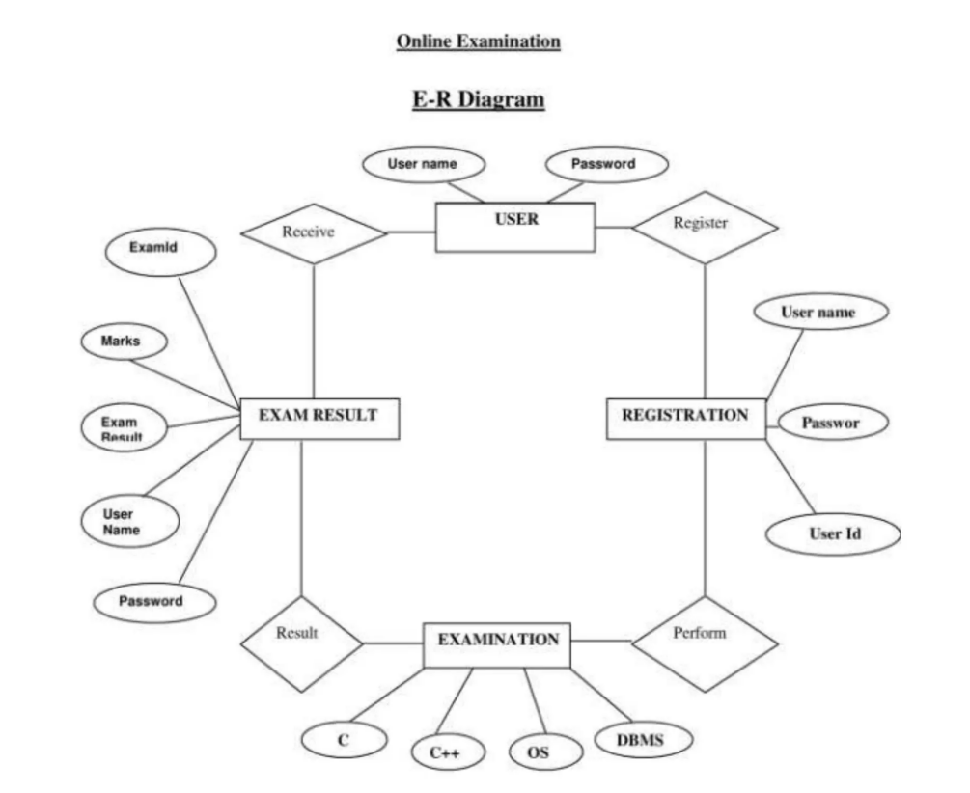

**FIGURE ER DIAGRAM :** 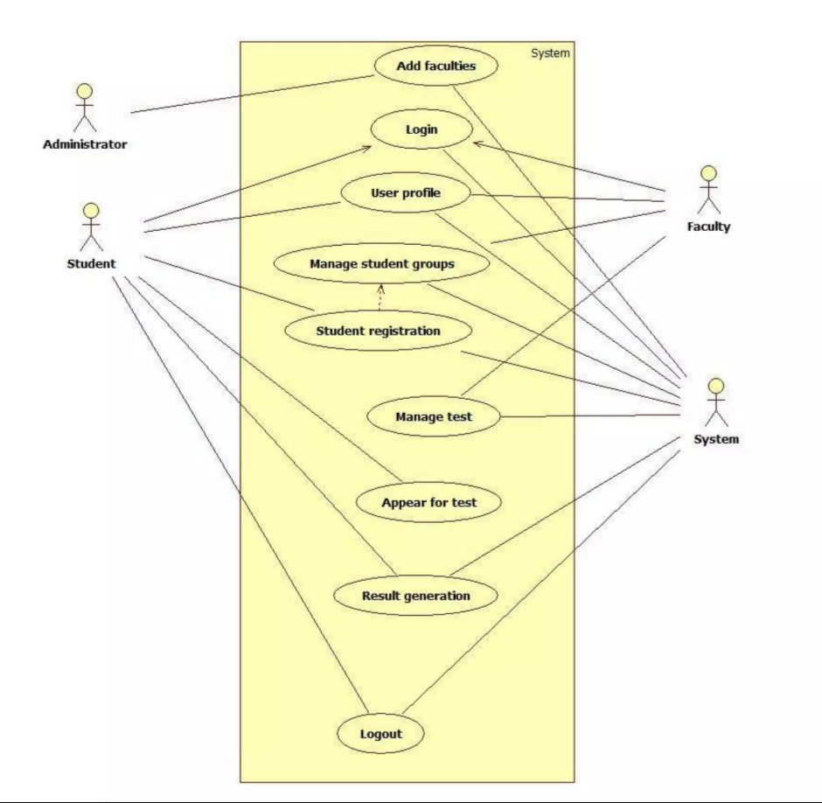

**Analysis Models:**

**USE CASE DIAGRAM:**

It defines scenarios what are the functions used in the project and mention the participant or actors involved in project and it should be a verb. Use case is represented as an eclipse with a name inside it. It may contain additional responsibilities.

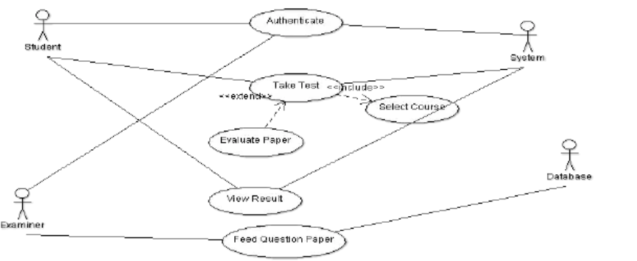

**ACTIVITY DIAGRAM :**

An Activity diagram shows sequential and parallel activities in a process they are useful for modeling business process.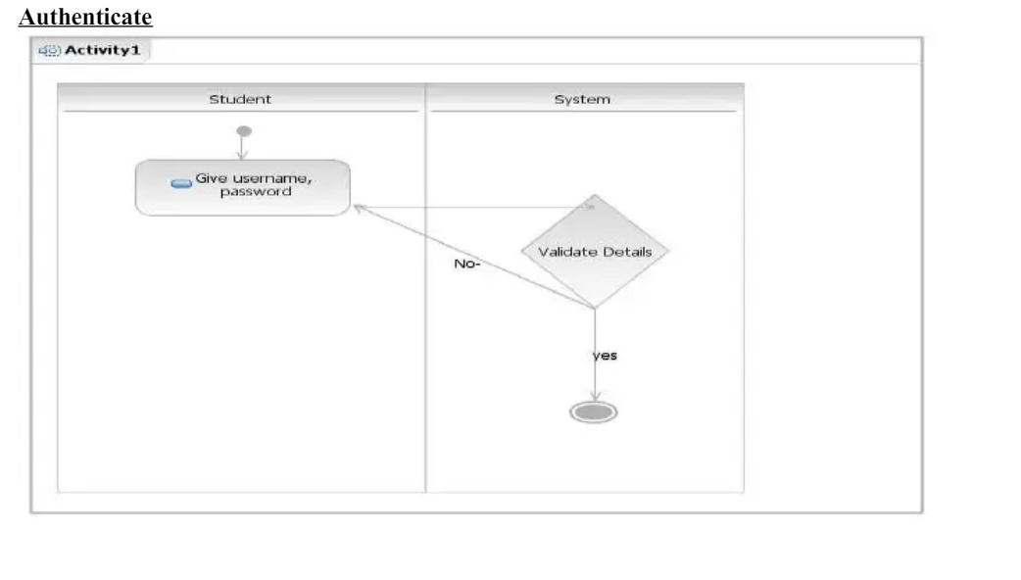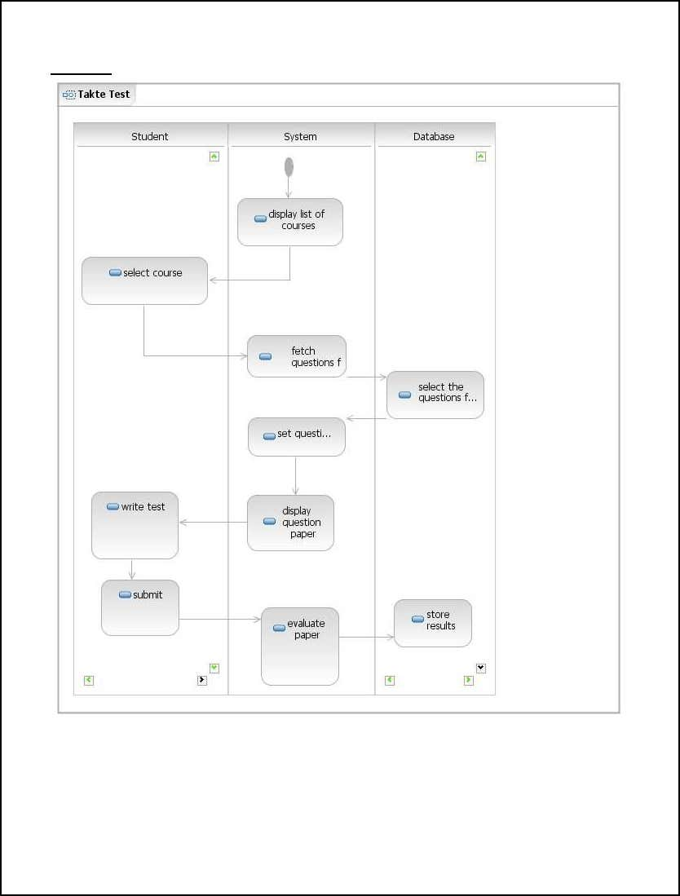

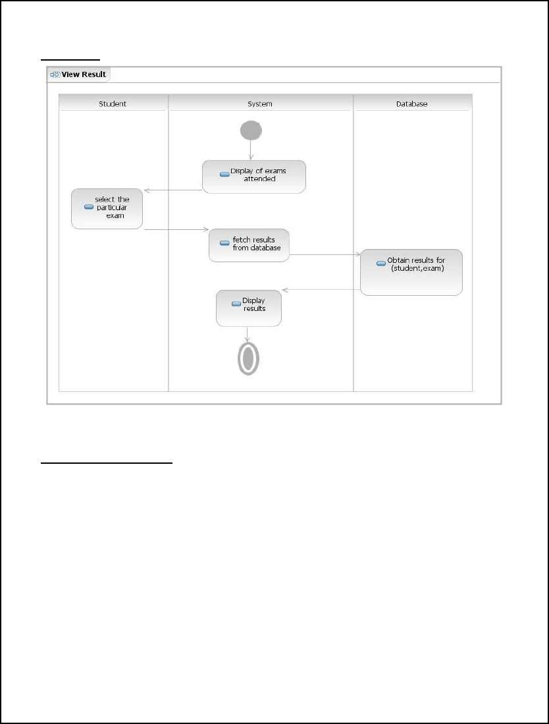

**UML CLASS DIAGRAM :**

It includes class diagrams to illustrate classes, interfaces and their associations .They areused for static object.

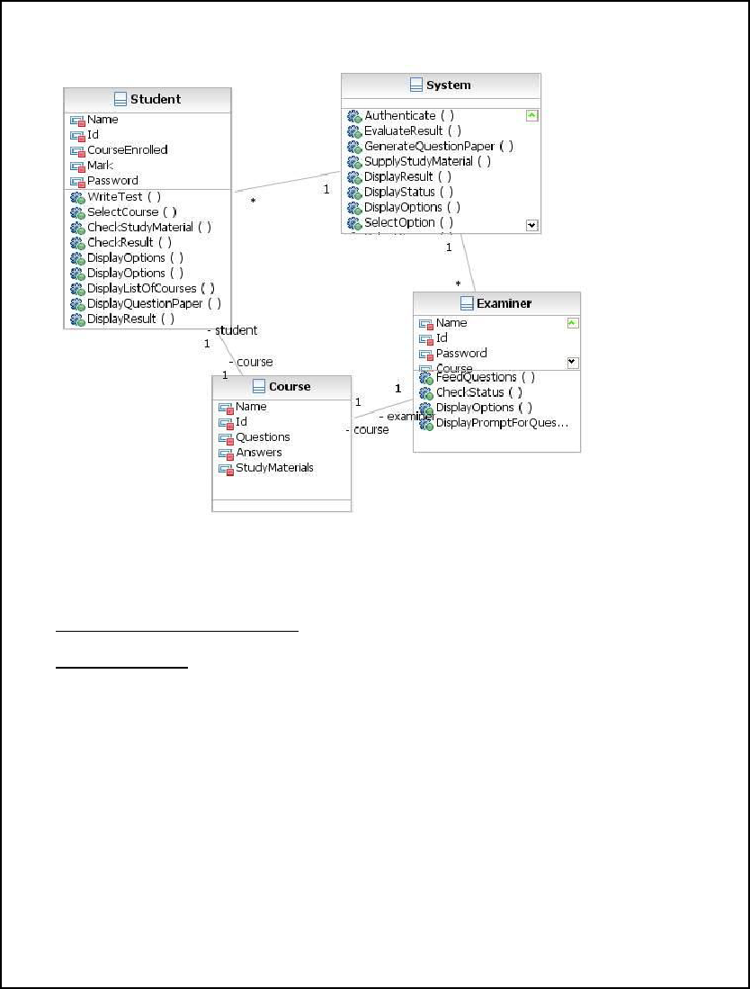

**UML INTERACTION DIAGRAM :**

**Sequence Diagram :**

Sequence diagrams are used as a notation that can illustrate actor interactions and the operations initiated by them.

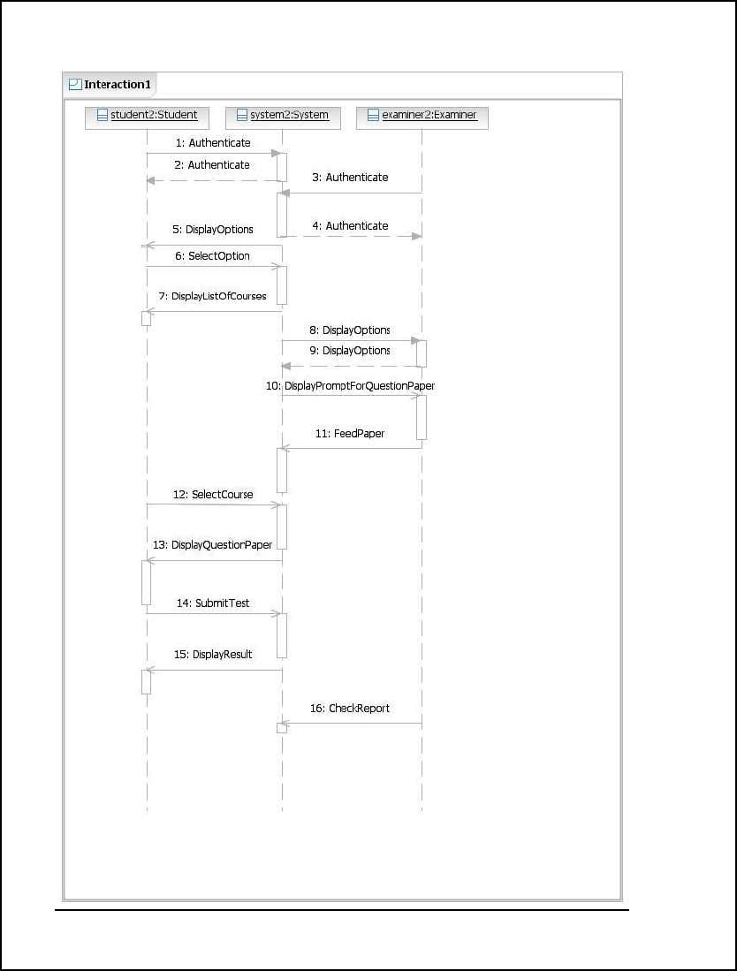

**COMMUNICATION DIAGRAM :**

Communication diagram is another form of interaction diagram. It represents the structural organization of a system and the messages sent/received. Structural organization consists of objects and links.

The purpose of communication diagram is similar to sequence diagram. But the specific purpose of collaboration diagram is to visualize the organization of objects and their interaction.

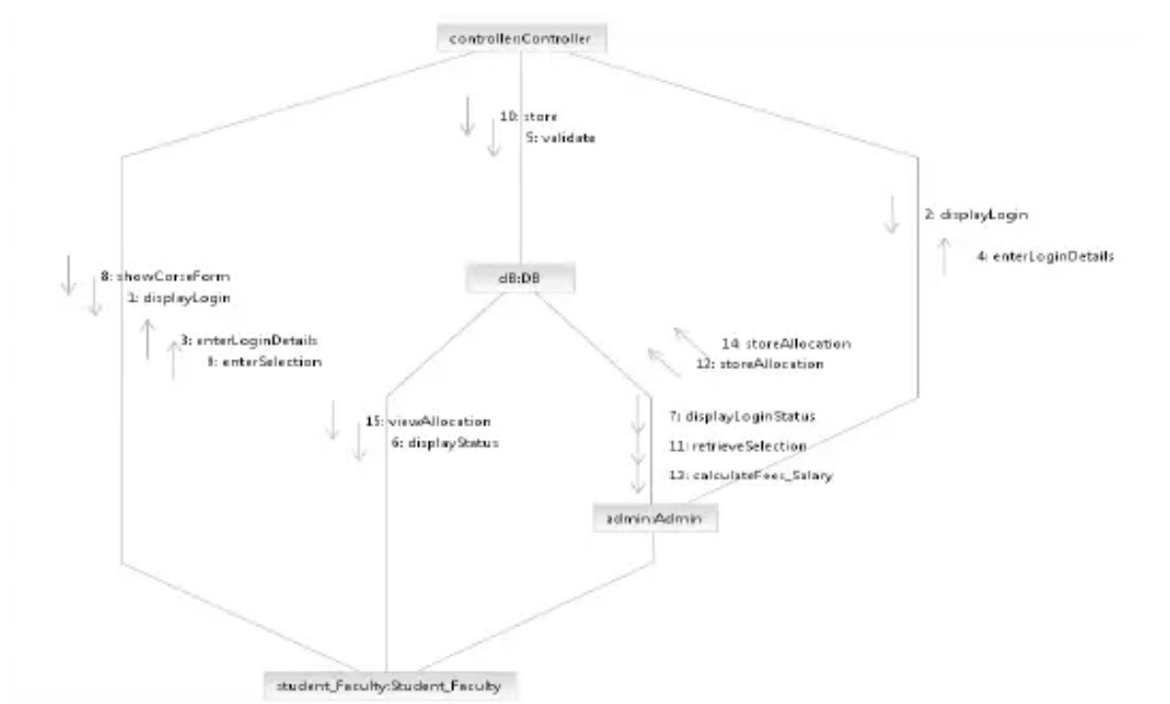

**UML STATE MACHINE DIAGRAM :**

Any real time system is expected to be reacted by some kind of internal/external events. These events are responsible for state change of the system.

State machine diagram is used to represent the event driven state change of a system. It basically describes the state

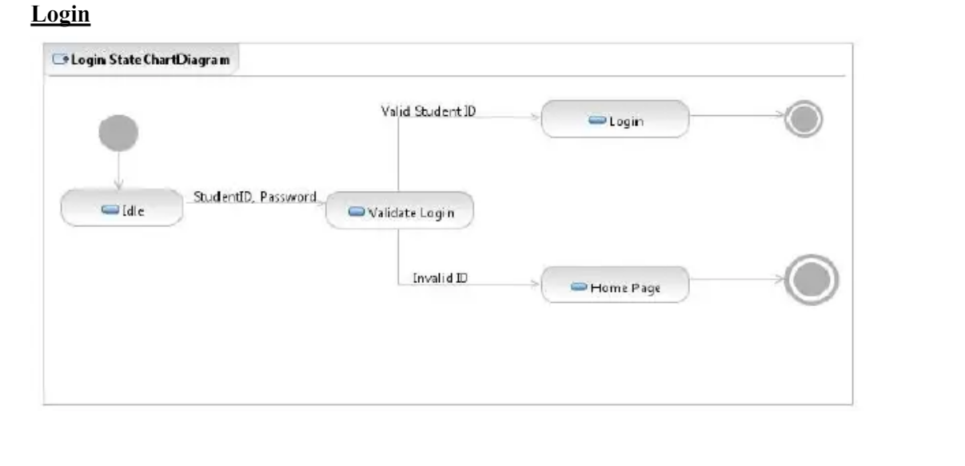

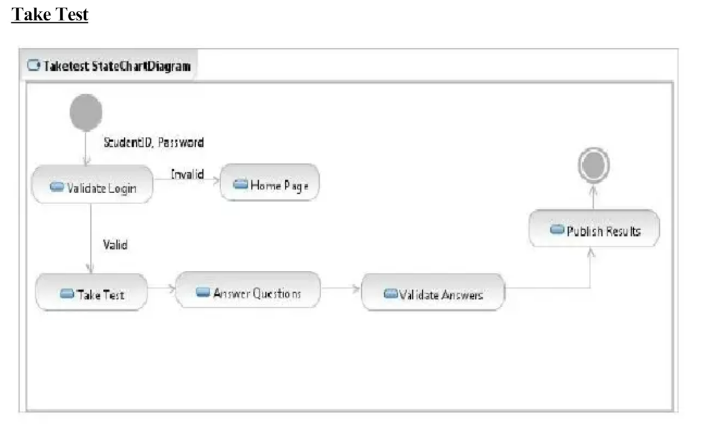

**UML COMPONENT DIAGRAM :**

Component diagrams are used to describe the physical artifacts of a system. This artifact includes files,executables , libraries etc.

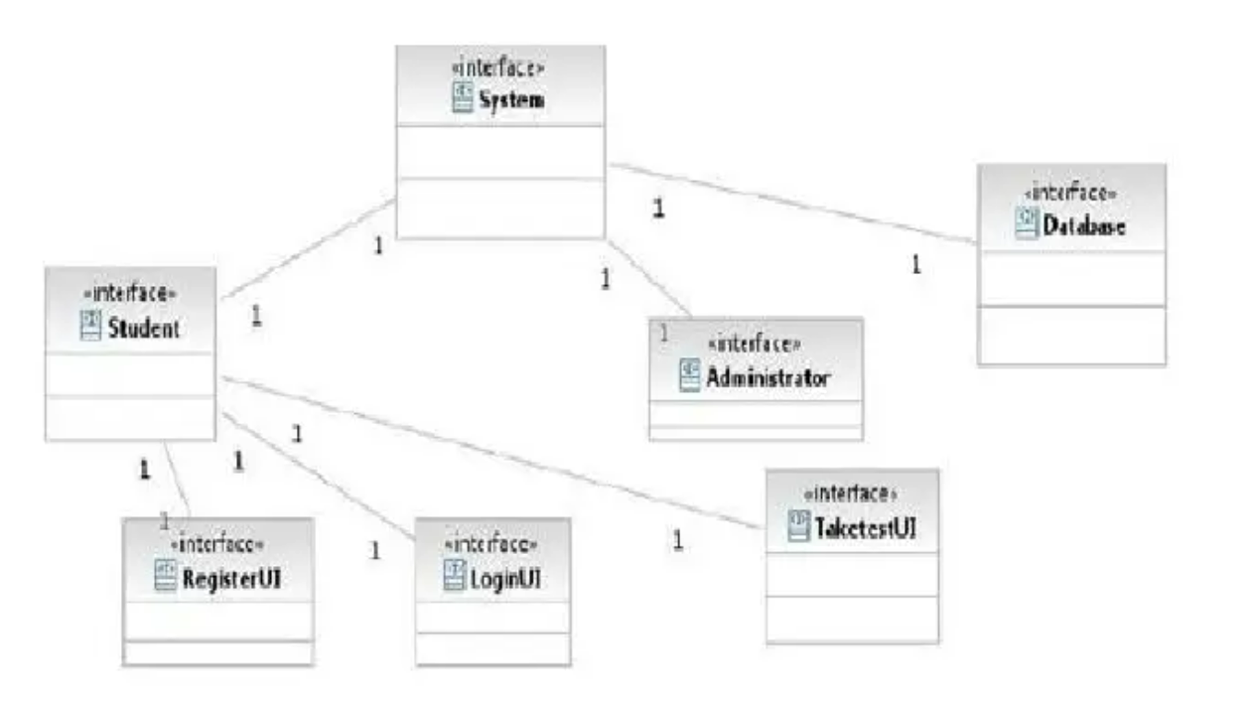

**DEPLOYMENT DIAGRAM :**

Deployment diagrams are used to visualize the topology of the physical components of a system where the software components are deployed. So deployment diagrams are used to describe the static deployment view of a system. Deployment diagrams consist of nodes and their relationships.

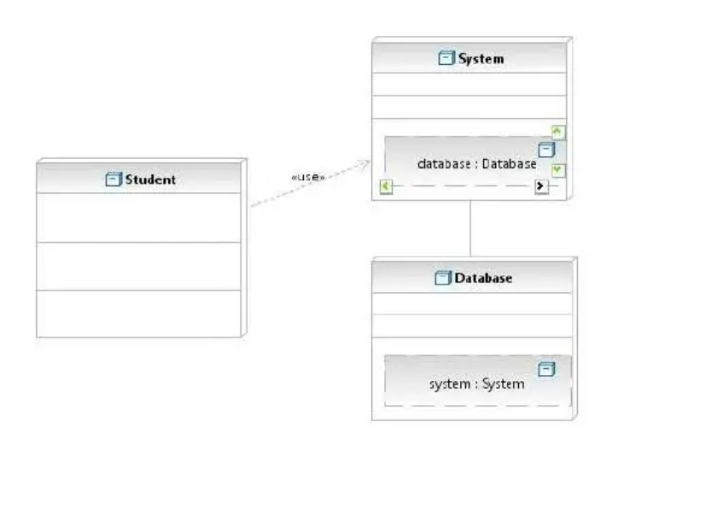

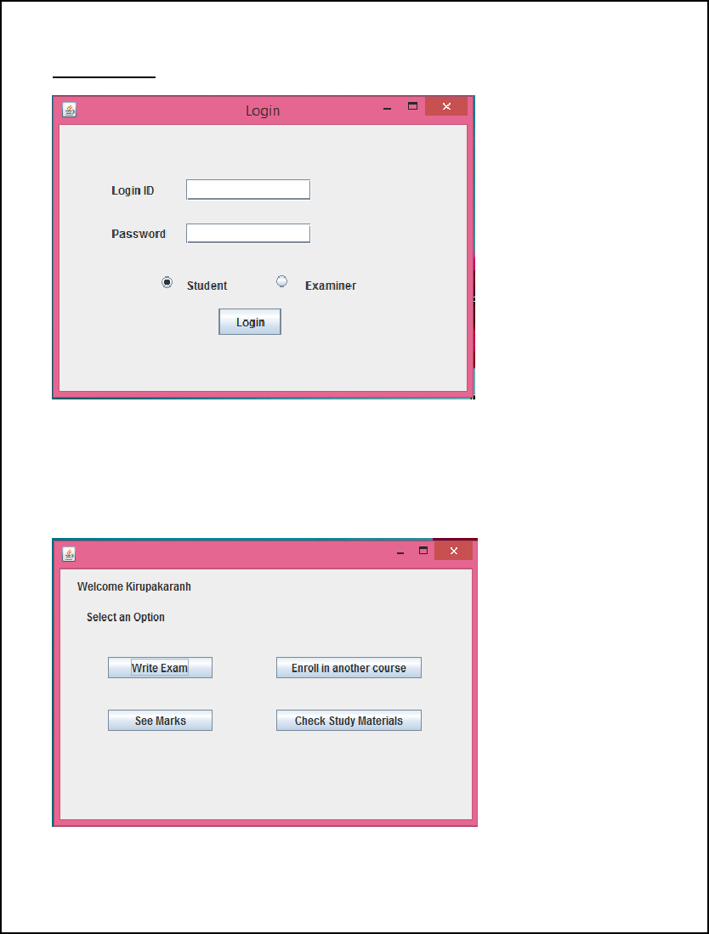

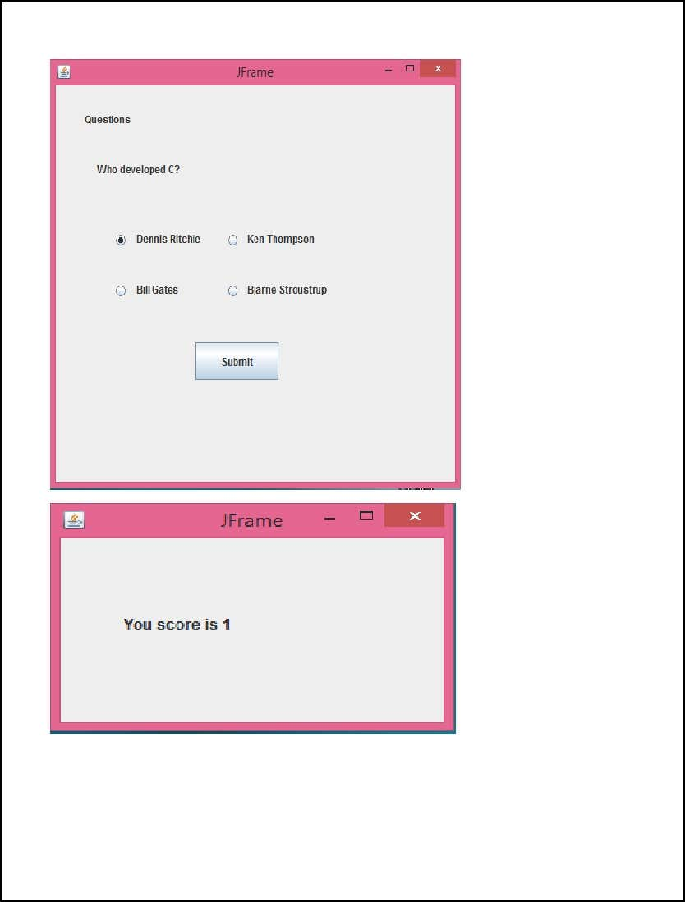

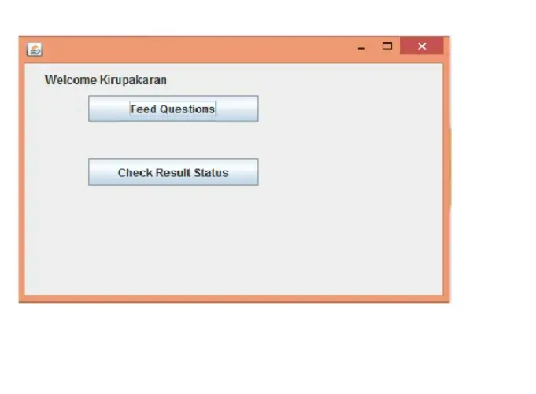

**RESULT:**

Thus UML models for Exam Registration System have been designed and implementation has been performed successfully using IBM Rational Software Architect.